*LAB # 11*

packages

# *OBJECTIVE:*

*An apparent detour to understand what is package is in java*

**Task # 01:**

*Create a package name bank_account, containing two classes named as Calculate_interest for customers and Calculate_special_Interest for employees respectively. Each class should carry a method of calculating the amount.*

**Code:**

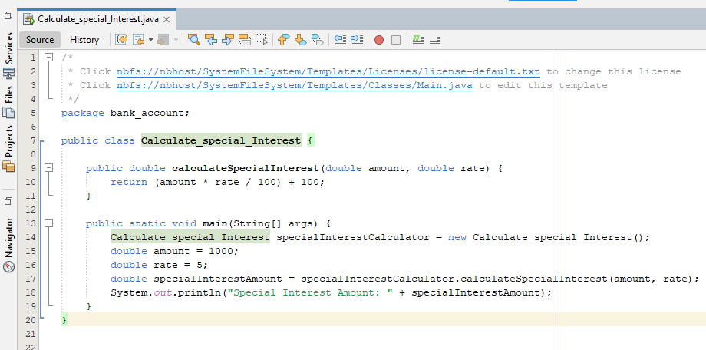

**Output**

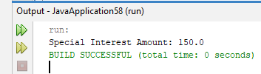

**Task # 02:**

*Import the bank_account package in to a class name Calculation_record and display the calculated amount of interest given to the customer and the employees respectively*

**Code:**

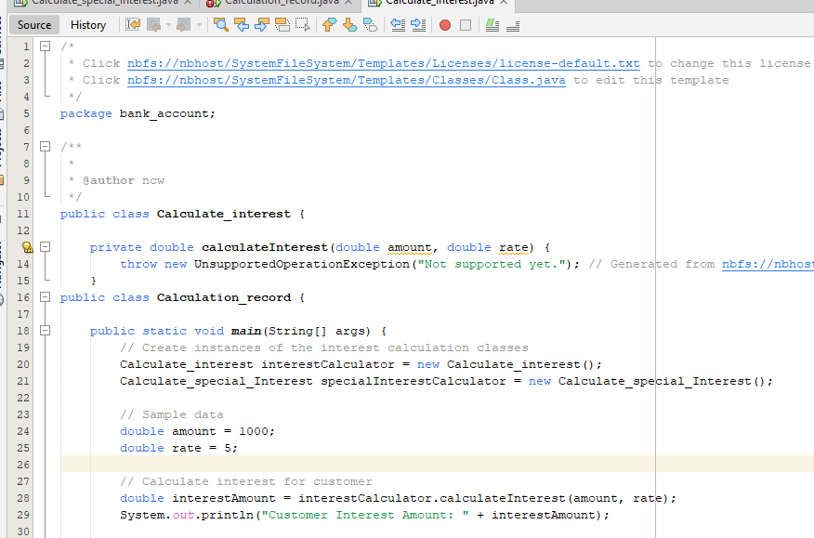

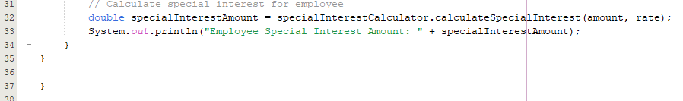

**Output:**

